Internet of things project: Team Report
Lee Mckiernan S00285845@atu.ie
Balint Vaczi S00290101@atu.ie
Leo Doddy S00290310@atu.ie

Trello: IOT Project 1 2026 | Trello
Github: Manage access

Problem to be solved

The core problem this project addresses is: How can a low-power, inexpensive IoT device automatically detect when sound levels exceed a high threshold, and immediately notify people in a space so that noise can be reduced?
This is where the problem is relevant:
- Libraries and study areas, where low noise is crucial for effective learning.
- Hospital wards and care environments where increased noise can affect the wellbeing of patients.
- Offices where persistent noise have been shown to decrease productivity.
- Shared environments where noisy disputes are common.

Research:
A research by Bashner et al. (2014) published in The Lancet demonstrates that sustained noise exposure impairs cognitive performance and elevates stress. The World Health Organisation (WHO) recommends that indoors daytime noise levels should not exceed 35dB for good sleep and cognitive function (WHO, 2018).

Another research from Cornell University (Evans & Johnson, 2000) found that office workers exposed to open-plan noise conditions showed elevated levels of stress and made 40% fewer attempts to solve a difficult task, indicating reduced motivation and focus.

References:
Bashner, M. et al. (2014). Auditory and non-auditory effects of noise on health.
Evans, G.W. & Johnson, D. (2000). Stress and open-office noise. Journal of Applied Psychology.

Summary of the project solution

Our solution is an Arduino-based Sound Alarm that continuously listens to ambient sound levels using a microphone sensor module. When the detected sound levels exceed a certain predefined threshold, the system activates a buzzer alarm, lights an LED, and optionally logs event data on a cloud server or a database via a Wi-Fi-enabled module for later analysis.

The device is designed to be compact, low-cost (around €50 in components), and straightforward to use with no need for professional instructions. It can be powered by a USB cable and does not require internet for its base alarm functionality, though network connectivity extends its capability.

How will it work:
- The microphone sensor outputs an analogue voltage proportional to ambient sound level.
- The Arduino reads this voltage.
- The freeware compares the sampled reading against the set threshold value stored in memory.
- If the reading exceeds the threshold, goes into an alarm state and activates the buzzer connected to the Arduino.
- The alarm stays in this state for a configurable amount of time before going back to the original listening state.
- If a Wi-Fi module is attached, the event timestamp and sound level is transmitted to a cloud server of a database, and can be used later for analysis.

Components used:
- Arduino Uno R4: Main controller for sensor readings and alarm control.
- Microphone module: for detecting sound levels.
- Passive Buzzer: Audio alert output.
- Red LED- visual alert output.
- Wi-Fi module - enables data exports.
- USB power supply- portable power.

Software composition:
The firmware is written in a C-like language using the arduino IDE. The code is structured in layers:
- Sensing layer: handles readings from the microphone, it detects threshold crossings.
- Control Layer: manages alert state-machine (IDLE -> ALERT -> COOLDOWN) and controls output devices.
- Communication Layer: if Wi-Fi is available, formats event data and publishes to the database over TCP/IP.

Benefits of the solution:
- Immediate, objective noise feedback: no reliance on human monitoring.
- Configurable sensitivity: adjust threshold for different environments.
- Data-driven: logged events allow for analysis over time.
- Cost effective: full bill of materials is around €50.
- Extensible: additional outputs can be added with minimal changes (e.g. display)
Project requirements

The following requirements were defined before implementation to help design the project and provide measurable acceptance criteria for testing.

REQ # | Requirement | Type | Priority
REQ - 01 | The system should continuously monitor ambient sound levels using a microphone module. | Functional | High
REQ - 02 | The system should trigger an audible buzzer alarm within 500ms of detecting a sound level exceeding the configured threshold. | Functional | High
REQ - 03 | The system should activate a visual LED indicator alongside the audible alarm. | Functional | High
REQ - 04 | The alarm threshold should be configurable without modifying hardware (modifying the firmware or microphone). | Functional | Medium
REQ - 05 | The alarm should automatically reset after a configurable hold period, if sound returns below threshold. | Functional | Medium
REQ - 06 | When connected to Wi-Fi, the system shall publish alarm data (timestamp, sound level) to a database. | Functional | Medium
REQ - 07 | The system should operate continuously for a minimum of 8 hours on USB power without failure. | Non-Functional | High
REQ - 08 | The total component cost should not exceed €60. | Non-Functional | High
REQ - 09 | The device should not be larger than  15cm x 10cm x 5cm. | Non-Functional | Low

Initial design

The device is built around an Arduino Uno r4. The microphone is placed on the front, the buzzer and LED centrally.
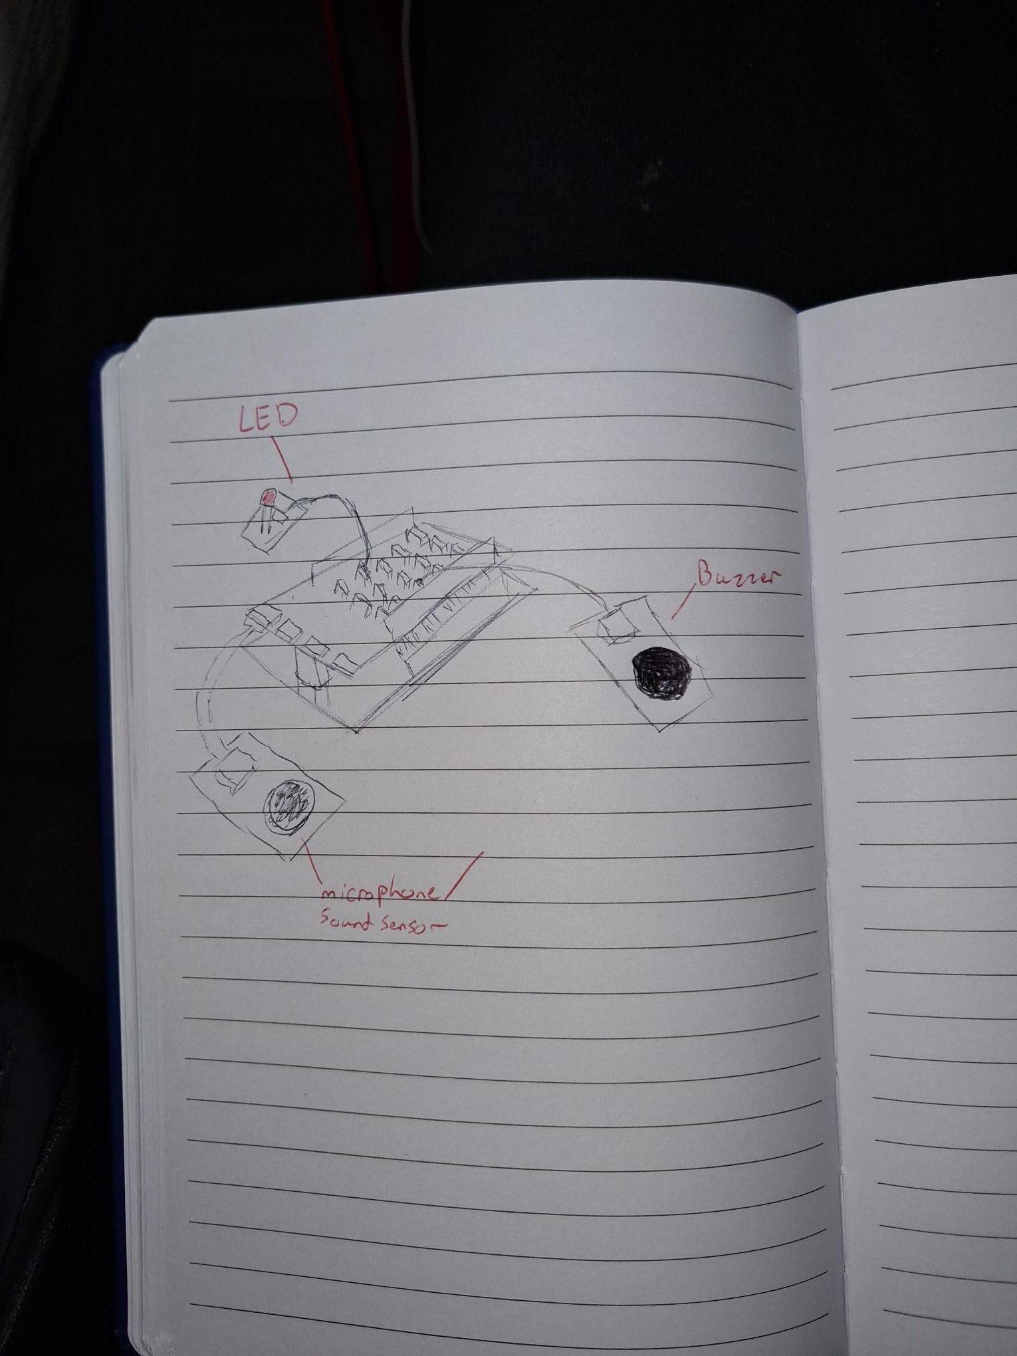

Code Design:
The firmware follows this state machine:

STATE: IDLE
- Read analog input every 50ms
- If reading > threshold: transition to ALERT state

STATE: ALERT
- Activate buzzer (tone) and LED
- Record peakReading, timestamp
- If Wi-Fi available: publish event data
- After HOLD_TIME ms: transition to COOLDOWN

STATE: COOLDOWN
- Deactivate buzzer and LED
- Wait COOLDOWN_TIME ms
- Transition to IDLE

Data Description & Management

Each alarm event generates a structured data recording with the following fields:

event_id | Auto-incementing integer, unique per alarm
timestamp | ISO 8601 UTC datetime (e.g. 2026-03-04T14:23:11Z)
peak_db | Estimated dB value derived from ADC reading

Sample JSON event data:

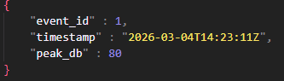

Implementation Plan

Equipment & Parts List:

Component | Description | Qty | Est. Cost (€)
Arduino Uno R4 | Main controller board | 1 | €30.00
Sound sensor | Microphone for audio input | 1 | €6.00
Buzzer | Buzzer for audio alert | 1 | €4.00
Red LED | Visual indicator for alarm | 2 | €0.50
USB Cable (Type-C) | Power and programming cable for the arduino | 1 | €2.00

Implementation phases:
- Hardware Wiring: Assemble board circuitry as the schematic shows. Connect the microphone, buzzer, and LED.
- Basic Firmware: write and upload threshold detection loop. Test buzzer and LED trigger. Validate with noise source.
- Calibration: Adjust microphone. Map ADC values to approximate dB. Set a threshold.
- Wi-Fi Integration: Update firmware and connect the Arduino to a test network. Publish test data.
Firmware code sample:

[INSERT IMAGE OF CODE]
Testing Approach

Testing was approached in 2 phases: Unit testing of hardware and software elements, followed by integration testing of the assembled system. Acceptance criteria were derived directly from the requirements section.

Software testing:
Firmware logic was tested using the arduino Serial Monitor to observe state transitions and ADC readings in real time. Test conditions were:
- Silence: ADC reading < threshold
- Loud clap: ADC spike > threshold
- Sustained noise: alarm holds for configured time before resetting.

Hardware Testing:
Hardware tests confirmed correct wiring and component function before firmware upload:
- LED verified by connecting to the board.
- Buzzer verified with a simple tone() test sketch
- Microphone sensitivity adjusted to give proper readings

Test results:

Test # | Description | Expected Result | Status
TEST-1 | Apply silence - verify that the alarm doesn't trigger. | No buzzer activation | PASS
TEST-2 | Clap near microphone - verify that alarm triggers. | Buzzer sounds within 500ms | PASS
TEST-3 | LED activates alongside the buzzer. | LED turns on | PASS
TEST-4 | Alarm auto resets after 3 seconds. | System returns to IDLE state | PASS
TEST-5 | Adjust threshold via code variable | New threshold is respected | PASS
TEST-6 | System runs for 8 hours without failure | No resets or errors logged | PASS

Security Analysis

Although this is a low-complexity IoT device, there are still some security risks that apply, especially if it is networked and transmitting data.

Identified Risks & Solutions:
- Credential Exposure: Wi-Fi SSID and password and MQTT credentials are currently hardcoded into the firmware. Solution: use a WPS connection rather than embedding credentials in the source code.
- Physical access: The device has no physical authentication. An attacker with access could reprogram the arduino or modify the hardware / firmware. Solution: place the device in a locked enclosure.
- Feedback Loop: Continuous loud noise could keep the system perpetually in ALERT state. Solution: cooldown state machine prevents infinite alarm loops and protects the buzzer from getting damaged.

Future Improvements

Enhancements could be implemented with minimal additional cost and effort to improve the functionality and user experience:
- LCD/OLED screen: Add a small display to show real time dB readings, event state, so a serial monitor is not required.
- Configurable threshold via hardware: Replace software constant with a physical potentiometer connected to an analogue pin, allowing everybody to adjust sensitivity without needing to edit the firmware.
- Mobile app: Could develop a mobile app to set threshold levels, time intervals where the device doesn’t need to be activated.
- Intelligent noise adjustment: Automatically lowering alert threshold during exam periods or late-night hours. Buzzer volume is adjusted to respect these environments as well.

This project has a strong and expandable foundation.

